Glustick vs ABS / Acetone testing notes
Aleph Objects – 8/15/2014

Summary: One of the critical features of the LulzBot mini bill be how well parts adhere to the bed, especially since the ability to print multiple materials is a key feature of the printer. Testing started in the Begonia phase of production to determine what the ideal temperature settings and preparation methods are for different materials. The tests for each material are being compared to those on another begonia phase printer with traditional Lulzbot bed preparation (85-105C on the bed, Lulz-juice on PET). For many materials the glue stick performed better than bare PET (HIPS, nylon, laywood, PLA). With it's tendency to warp, ABS was more difficult but with a thicker coat of glue stick the amount of warp was comparable to the baseline of lulz juice on PET.

The bottom surface of the parts tends to be much more matte on the gluestick than on the lulz-juice and PET, but you can make it a smoother surface by wiping the glue around with a wet cloth while warm.

I recommend going with Uhu glue and bare glass on the mini's rather that PET and lulz juice

Comparison of Lulz-juice to gluestick, both with beds @ 105C:
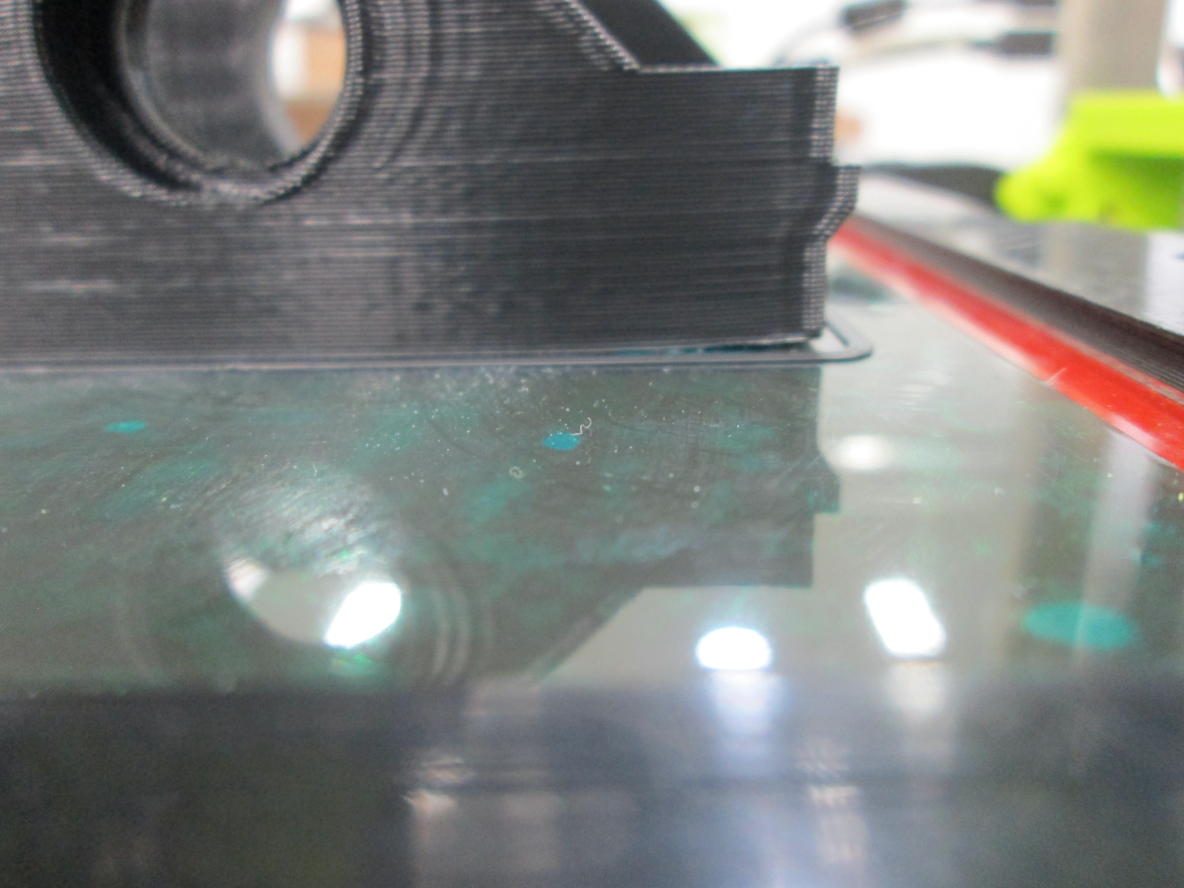
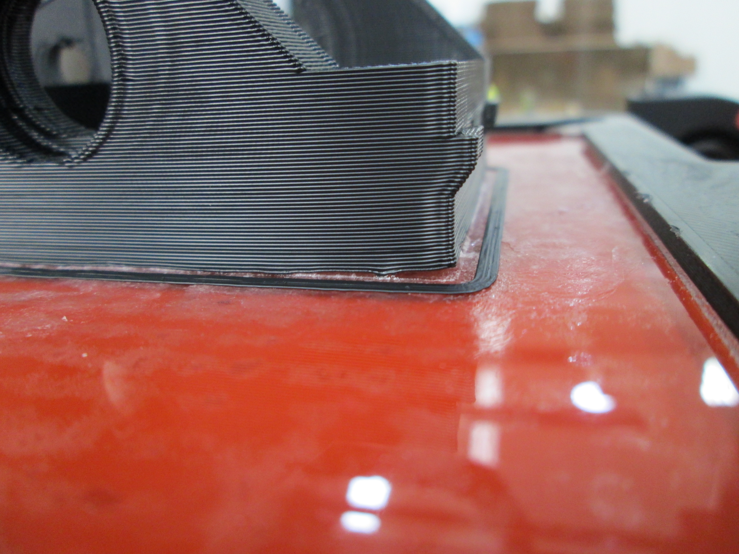
The part shown above is currently one of the more difficult parts that we currently print in the cluster, necessitating that the bed temperature is raised to 105C with PET and ABS/acetone. Warping could be prevented by adding a brim to the part, but printing that close to the edge of any printer's bed is going to cause issues.

Gluestick testing data available here:
/home/aleph/shared-j/devel/lulzbot/mini/begonia/testing/gluestick_testing
Testing Photos available here: file:///home/aleph/shared-j/devel/lulzbot/mini/begonia/photos/glue_testing

We'll continue to develop and refine the temperature presets as slic3r profiles are developed, but here are the temperature settings that have been working:

ABS: Multiple coats are fine, 105C on the bed
PLA: thinner coat than ABS, 65-75C on the bed seems to work fine
HIPS: Thick or multiple coats of glue , 65-85C bed temp
Nylon: Thick coat – 85C on bed temp – may need to increase for higher temp Nylons

